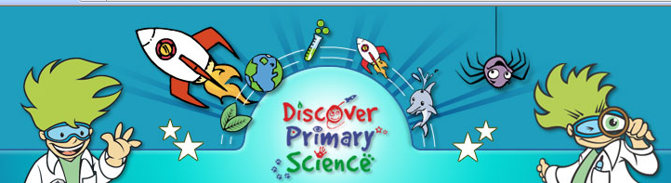

Discover primary Science Awards of Excellence, 2008

The Discover Primary Science Awards of Science Excellence ceremonies 2008 were bigger and better than ever, with 654 schools receiving the Discover Primary Science awards.
Twenty ceremonies were held during June at eight locations around the country, including the Maryborough house Hotel in Cork. Students and teachers alike enjoyed a presentation from the NASA astronaut, Dani Tan, about his time on the space satation. The interactive science shows that followed had teachers and pupils on the edge of their seats, with plenty of booms, bangs and puffs!
Molly Cool had great fun meeting all the budding young scientists, and loved stepping in for photos.
Congratulations to all who received an award, and don't forget that you can start work on your Discovery Log in September for next year's Awards of Science Excellence. To find out more, visit: http://www.primaryscience.ie/site/awards_08_eoi.php

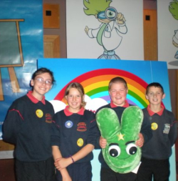 | 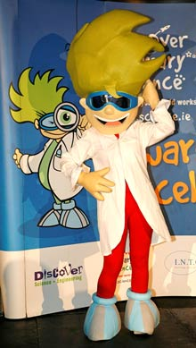
Daniel Harrington, Gurranesig National School, Kilbrittan, winner of the APC word search competition at the Cork Awards of Science Excellence ceremony. Daniel is pictured with his classmates. | Molly Cool, posing for pictures!

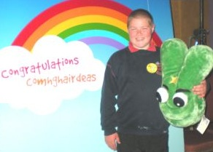
Mr. Daniel Harrington Gurranesig National School, Kilbrittan, winner of the APC word search competition at the Discover Science and Engineering Awards of Excellence with his prize, a huge, cuddly G.I. Jake!

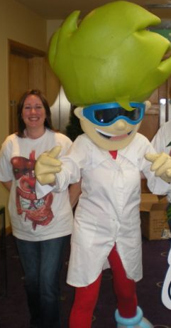 | Left: Ms. Grainne Heelan, APC the real Molly Cool with at the Discover Science and Engineering Awards of Excellence ceremony in Cork!  The awards programme is organised by Discover Science & Engineering (DSE), the Government's national science promotion programme, which aims to increase interest in science, technology, innovation and engineering among students, teachers and the public.

