Microbe Magic Limerick Competition, 2008

Congratulations to the winner of the Microbe Magic Limerick competition – Ms. Clare Forde of 4th class, Firmount National School in Co. Cork! Clare was the winner of an MP3-player and a cuddly GI Jake! Click here to read highly commended and other entries!

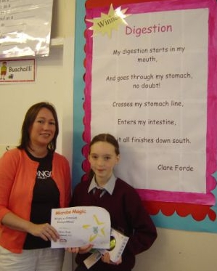

Ms. Clare Forde (right), 4th Class, Firmount N.S., Donoughmore, Co. Cork, winner of the 2008, Microbe magic Limerick Competition, accepts her prizes from Ms. Grainne Heelan, APC

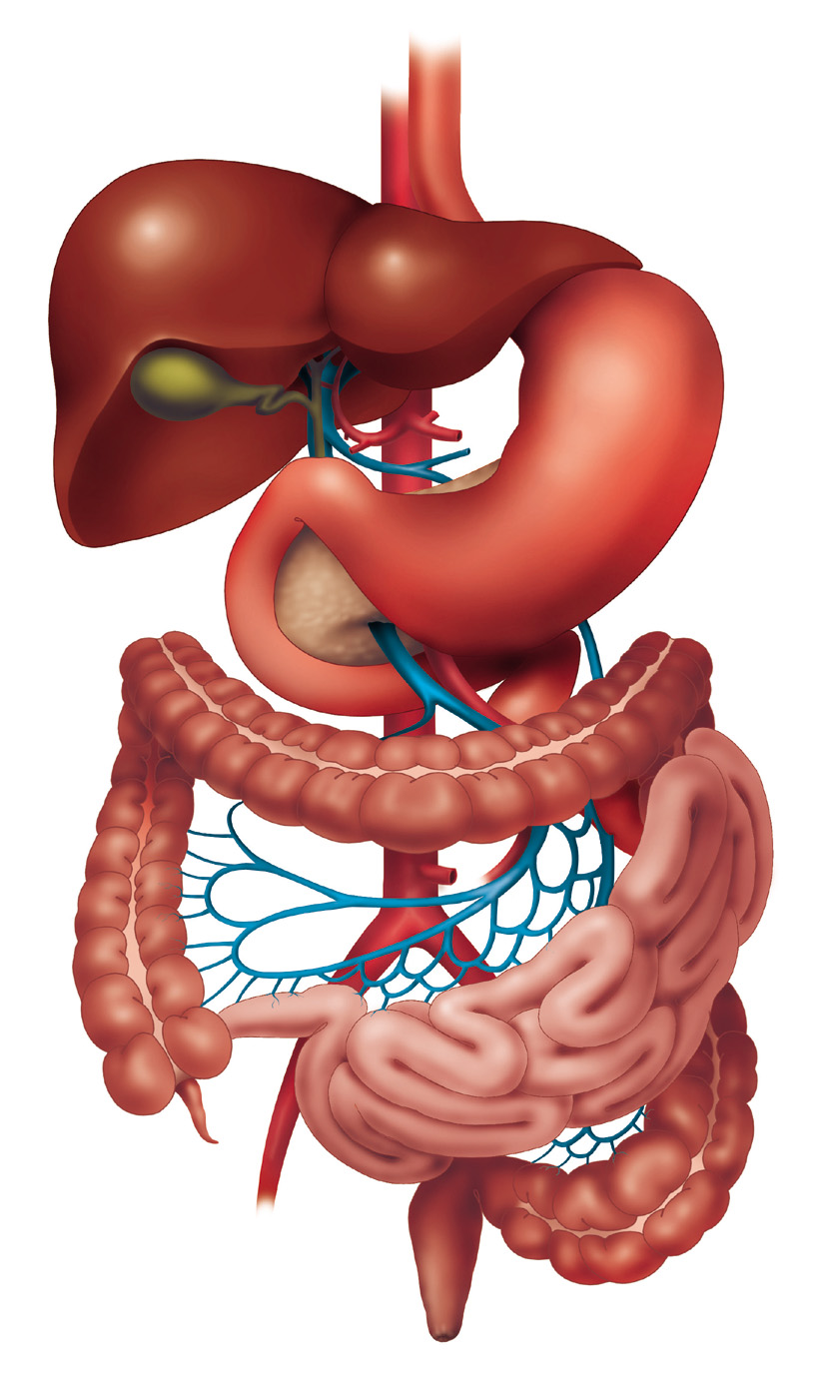
South!
Winning Limerick:

My digestion starts in my mouth,
And goes through my stomach, no doubt!
Crosses my stomach line,
Enters my intestine,
And it all finishes down south!

Highly Commended Limericks:

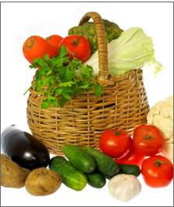
To answer this simple question,
You’ve got to have good digestion,
Health food in all day,
Will keep sickness away,
Just follow this simple suggestion

Hannah Crowley, 5th Class, St Joseph’s Girls National School, Skibbereen, Co Cork

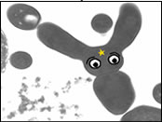
There once was a chocolate bun,
Covered in bubble gum,
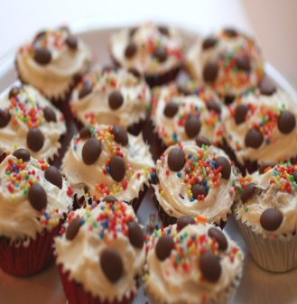
I popped it in my mouth,
And it headed south,
Microbes and enzymes all had fun.

Kieran Scally, St Brendans N.S., Annaghdown, Co Galway

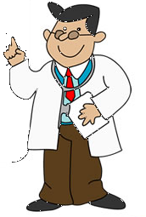
Digestion is important to me,
It involves breakfast, dinner and tea,
To get good from my food,

It must be properly chewed,

And all the doctors will surely agree.

Claire Murphy, 4th Class, Dromleigh National School, Macroom, Co Cork

Limerick competition entries:

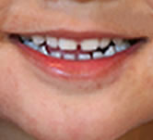
My Daddy always gets digestion,
His tummy is trying to make a suggestion,
When he fails to chew all his supper,
He gets a pain in his upper,
To chew his food more is my suggestion,
To solve his indigestion.

Robert Crowley, 6th Class, Ballinspittle N.S., Co Cork


Food goes in and floats around
And gets quite slushy,

Our digestive system gets to work
To get rid of this food in quite a hurry,
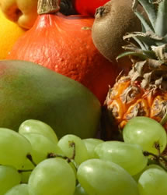
So drink plenty of fluids,
Chew well, eat healthy, exercise daily,
And help this vital part to stay healthy and strong,
While its doing such an important job.

Shanna Kay Healy, 3rd Class, Minane Bridge School, Cork

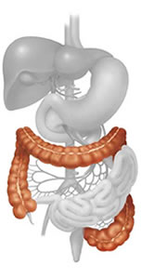
Digestion, digestion, digestion
It happens in my large intestine,
The good food stays in,
The bad food gets binned,
Thank God I have no indigestion.

Tadhg Gleeson, St Brendans N.S, Co Galway

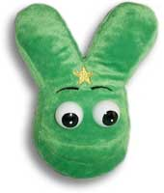
There was a germ called GI Jake,
He sure eats a lot of nice cake!
One fine day he got fat,
And so then when he sat;
He said ‘no more cakes I will bake!’

Ciara Mulry, 6th Class, Scartleigh N.S, Co Cork

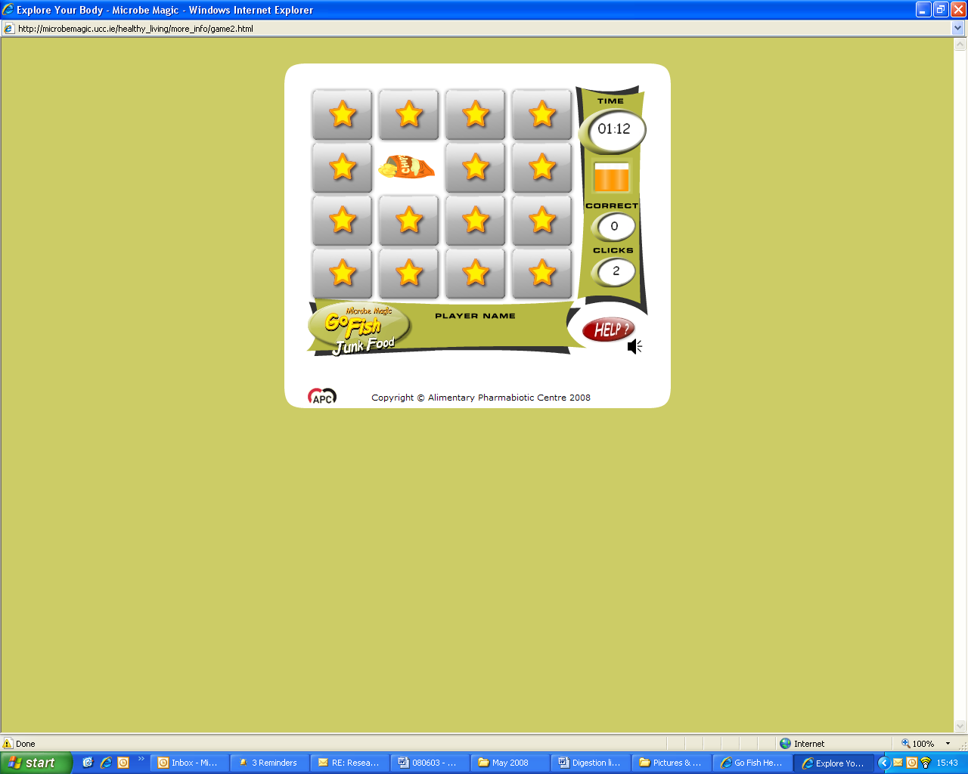
Sweets and crisps they are so yummy,
But sometimes they give me a pain in my tummy,
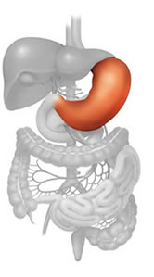
Fruit and veg won’t give you indigestion,
And are better for your digestion,
Well that’s according to my Mummy.

Aisling Meehan, St Brendans N.S, Co Galway

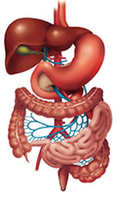
The foundation of a good digestion,
Is having a healthy intestine,
Don’t eat too much
Like chocolate and such,
And you’ll never get indigestion!

Aoife Conroy, St Brendans N.S, Co Galway

