Comhghairdeas to Sonata Karnickaite!

Check back next week to see other entries from this class and from other schools!

There were lots of really excellent entries to this competition but unfortunately there can be only one winner. Congratulations go to Sonata Karnickaite, 6th class, Scoil Mhuire, Ballincollig, pictured here with her mum.

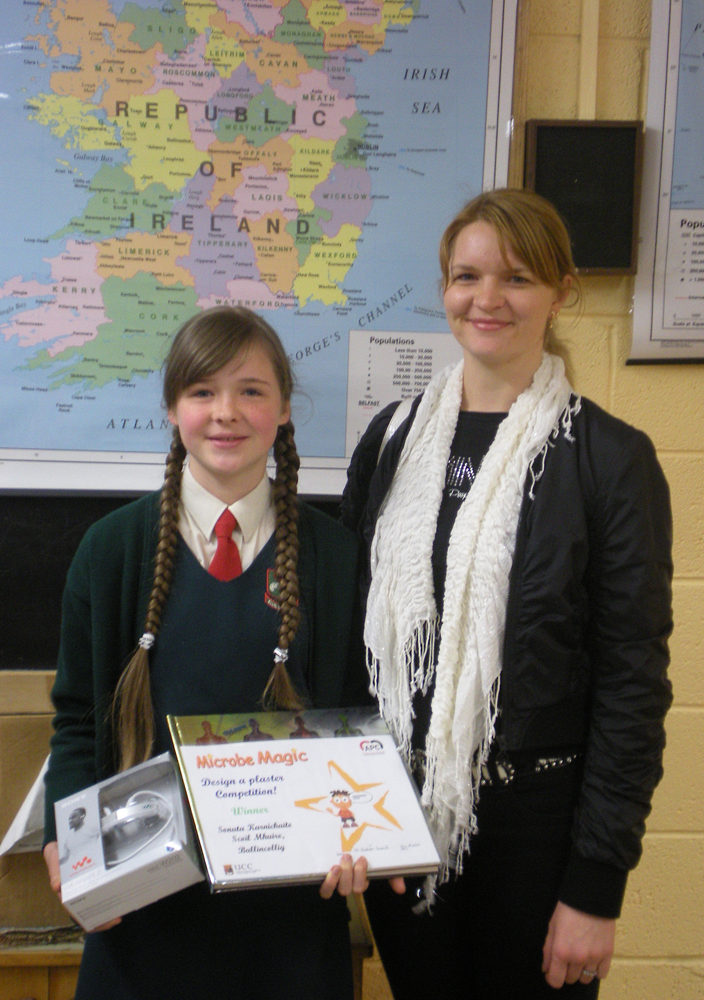

Sonata won a state-of-the-art MP3 player and received a certificate from the Alimentary Pharmabiotic Centre. In recognition of the high level and quality of entries, the entire class received a surprise gift of a science discovery book.

Sonata's prize winning wining entry:



