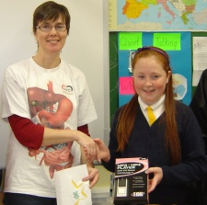
Kate O’Donnell, from St. Mary’ Senior School in Dunmanway, Co. Cork was the winner of the APC Scientist @ Work Art Competition from the Microbe Magic newsletter. Kate was the lucky winner of an MP3 player and a cuddly GI Jake from the very high quality entries!

The standard of entries was very high and the judges had a very difficult time choosing a winner. You can see the highly commended pictures below.

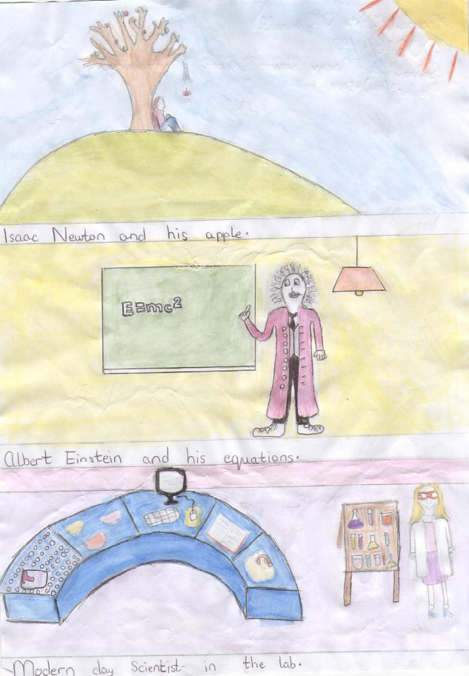
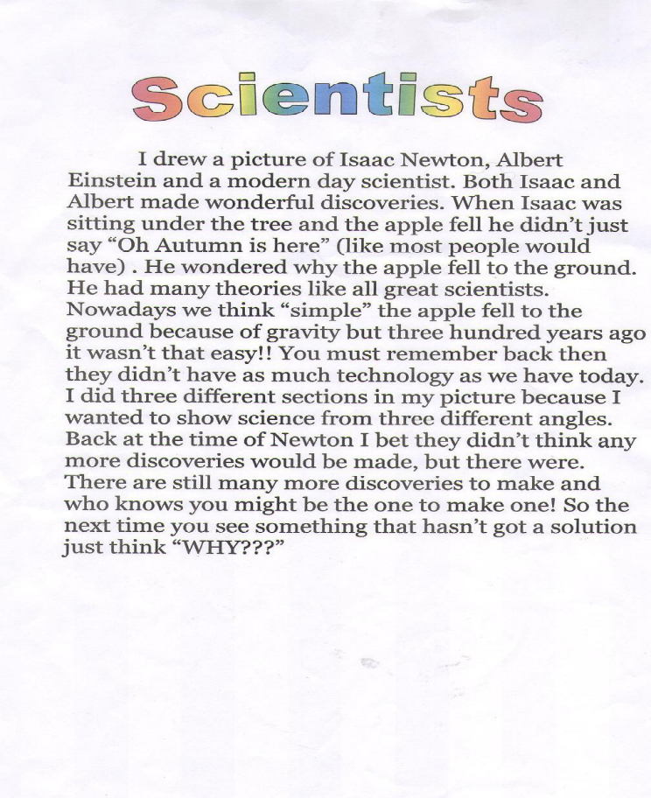

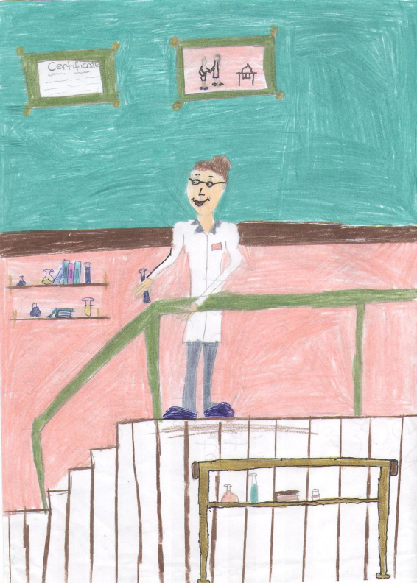
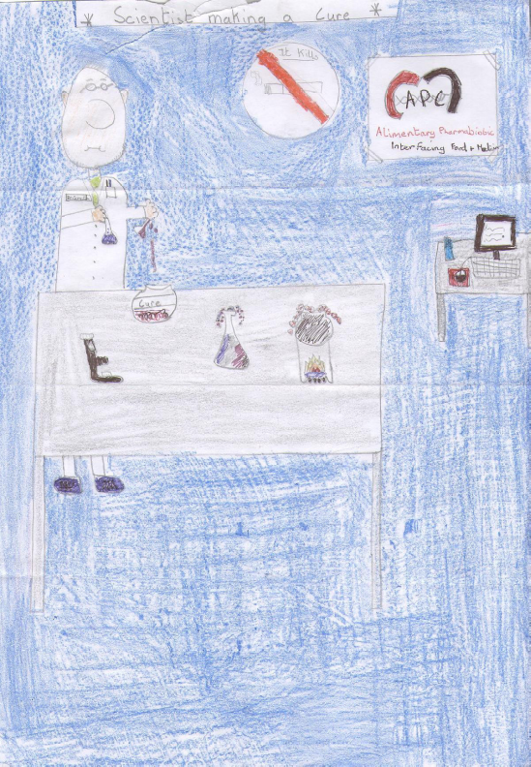
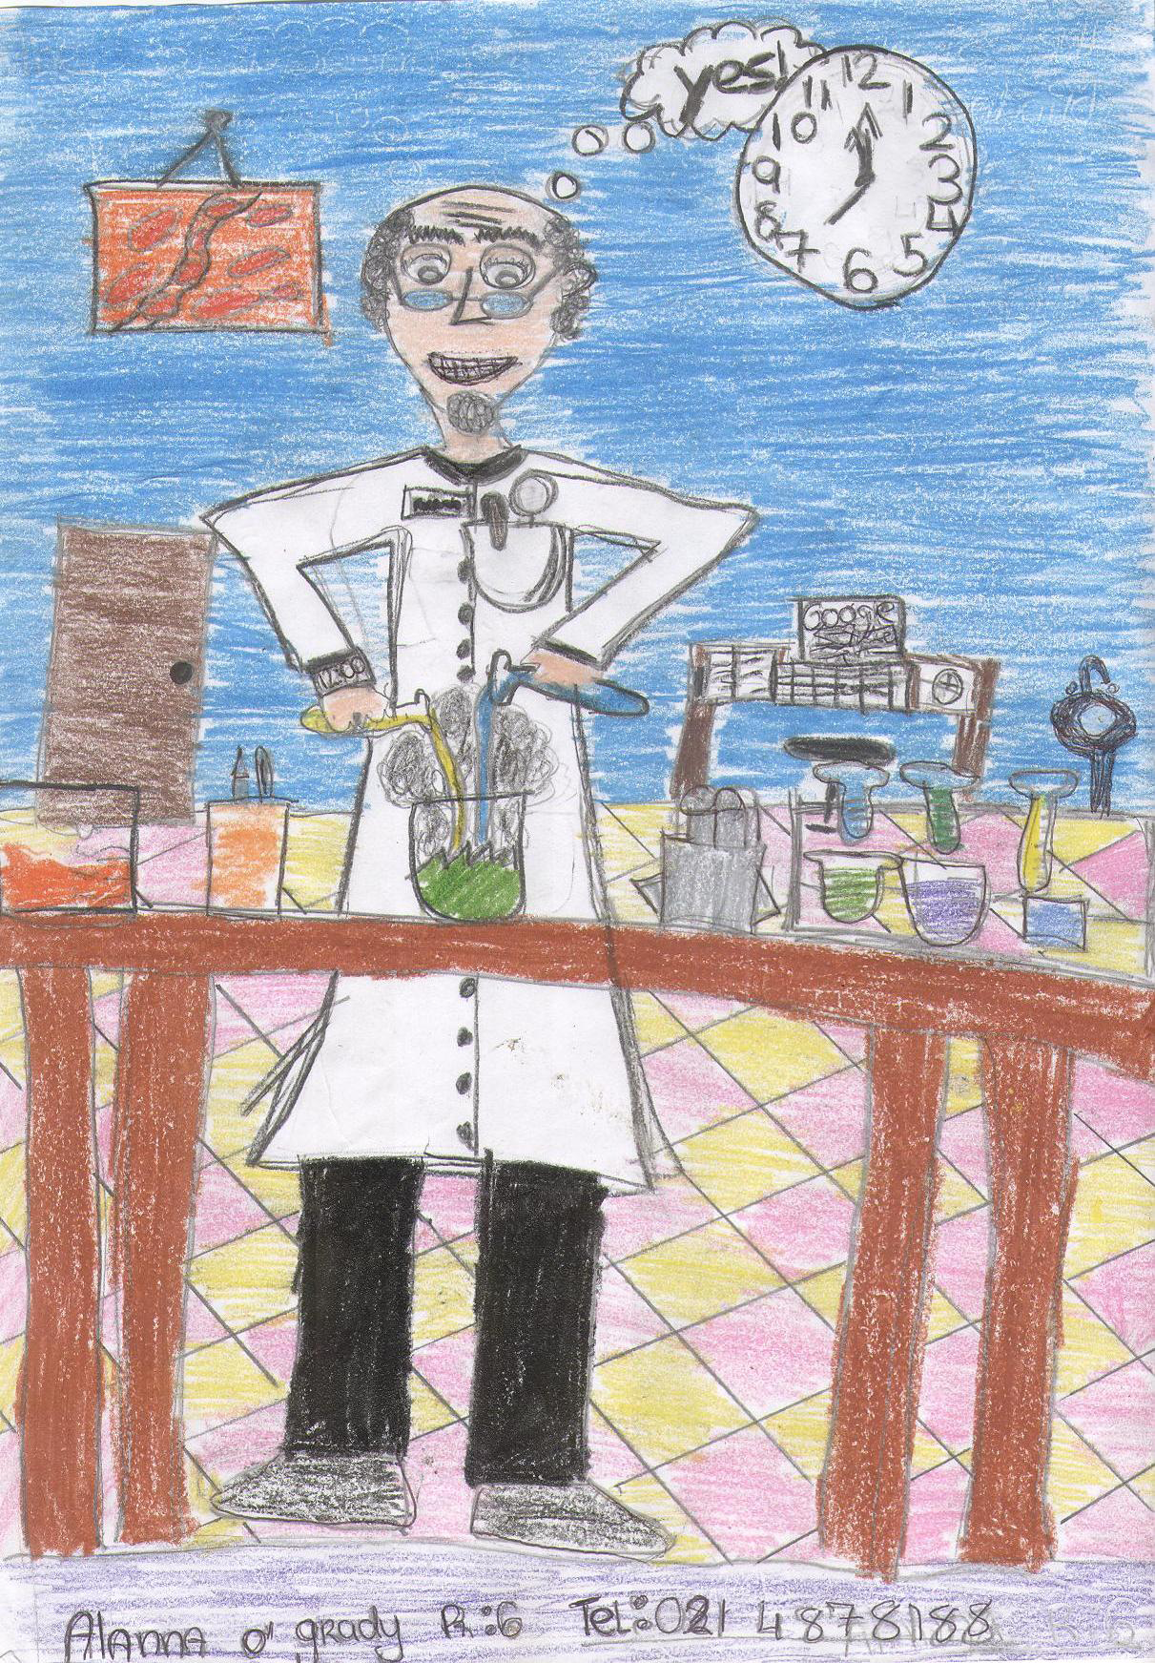
Ciara McCarthy, Conna National School, Co. Cork, was highly commended for her picture of a scientist at work. Ciara says: “This scientist is making a cure for a disease. She is walking down the stairs with a toxin, passing her certificate for ‘Scientist of the Year’!”

Allana ni Ghrada, Gaelscoil ui Riordain, Baile an Chollaigh, Co. Chorcai was highly commended for her Scientist @ work Art Competition picture of a scientist at the bench!
Marie O’Leary, Dromleigh National School, Co. Cork, was highly commended for her picture of a scientist at work. Marie says: “This scientist is making a cure for cancer. He is mixing medicine to make it. If he gets the cure right, he will be famous and help a lot of people!”

If you would like to have a picture, essay, poem or anything else shown on the Microbe Magic website, just contact Mike at:

MicrobeMagic@ucc.ie

or you can write to him at:

Mike @ Microbe Magic,
Alimentary Pharmabiotic Centre,
5.09, BioSciences Institute,
University College Cork,
Ireland.

